Save Our Nation Crusade, NOW!

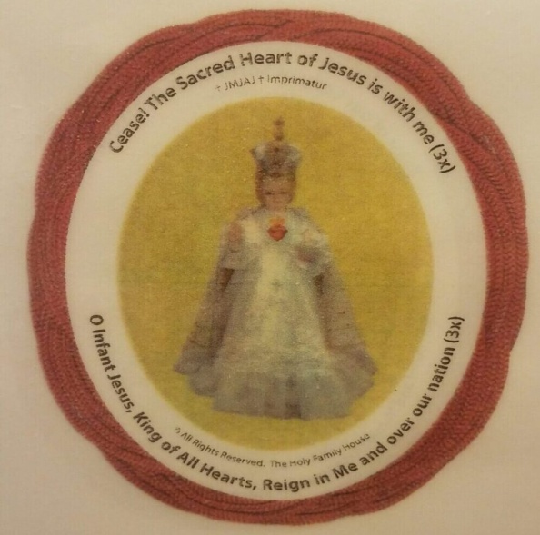

Do you like the things, that are going on now, in the U.S.? The Culture of Death, which pervades almost every area of our life? In the “land of the free and the home of the brave”, the most dangerous place for a person is in his mother’s womb. Now, increasingly, the most dangerous place for an elderly, sick, or handicapped person can be a medical, nursing, or hospice facility. If we don’t have the right to life, we will never be able to enjoy liberty or pursue happiness.

As God blesses or curses a family, according to the father’s behavior, so God blesses or curses a nation according to how its spiritual fathers, the Catholic Bishops, behave. As t.he U.S. Catholic Bishops have not efficaciously opposed the Culture of Death, The Lord is chastising the U.S. What can WE do?

Let's look at another country, chastised by Jesus:
Jesus Christ appeared several times to St. Margaret Mary Alacoque. “Jesus told St. Margaret Mary: ‘The Eternal Father…wishes to make use of the reigning monarch of France (Louis XIV) to proclaim public devotion of reparation to The Sacred Heart”…In return, Our Lord promised that the king would have His blessing and protection from all his enemies.” (http://www.thecatholic travelguide.com/ParayLeMonial.html).

When the King refused to do so, France was soon beset by wars, and around 100 years later, A.D. 1789, the French Revolution tore France apart and transformed it from a Catholic nation to a secular one.

Later on, in A.D. 1871, when the Germans had almost overrun all of France, the laity petitioned the Archbishop of Paris to enthrone Jesus’ Most Sacred Heart as King, over France. Incredibly, the Germans refrained from taking over France and peaceably left.

We recently, allowed a communist to be elected President and two communists to be elected Senators from Georgia. Let’s not sit by and watch the U.S. explode in a civil war – let’s recognize and celebrate Jesus’ Divine Right to reign over us and be blessed - not chastised - by Him.

PRAY:

www.theholyrosary.org/MaryUndoerKnots and make the novena, NOW, in honor of the Feast of Mary and Joseph's Espousals (January 22/23) when the core of The Holy Family was formed. As Jesus listens very much to His Blessed Virgin Parents, we should go to them, and urgently request their Most Holy Help to enthrone The Infant Jesus' Most Sacred Heart, as King, over the U.S., ASAP!

FAST: Give up a food/drink, unneces-sary to good health, and offer this up for this Enthronement to take place, NOW!

Fax/Write/E-mail/Call Pres. Trump, your Bishop, Archbishop José H. Gómez of L.A., USCCB Pres., and urgently request that they make this Enthronement, Now!

Copy & Distribute: this handout;

E-mail this web address to your list: http://www.TheHolyFamilyHouse.org/ Christus-Rex/

Contact: Catholic students, Priests, Deacons, religious communities,… and get them to join this Crusade.

Holy Masses: Have Good Priests cele-brate them for this Novena. Priests: Celebrate an extra Holy Mass, daily, for this Novena, even if Biden is put in place, as President – we will need them, then, more than ever!

© & ® The Holy Family House, Feast of our Lady of Victory, A.D. 1/13/2021 and on. Can be copied & distributed with legible attribution.
E-mail us: EDM@TheHolyFamilyHouse.org

+A.M.D.G.

